Level 1 ALU Design
Version 0.1
David Lowther

Revision History
19 Jun 2026 | First Draft
19 Jun 2026 | Edit 3.7 to correct copy / paste error about signals used to store data in the flags latch  Edit 3.6 to correct a typo: change READ to WRITE
20 Jun 2026 | Due to today’s changes in ref 2 (CpuDesign.docx) made the following changes to this document:  3.2 Edit ref 2 section number for where to find rules about reading from data bus  3.6 Edit ref 2 section number for where to find rules for writing to the data bus
30 Jun 2026 | Removed READ and WRITE from Figure 2  Removed READ and WRITE from Table 1  Removed WRITE from 3.7  Edited 3.7 to allow for use of a “level triggered” latch. Previously it assumed an “edge triggered” latch would be used. I.E. a choice can be made to use whichever type of latch is most conveniently available.
4 Jul 2026 | Changes to match ref 3 signals changing from active low to active high.  Only affected section 3.7

Contents
1 Introduction 1
2 Overview 1
2.1 ALU Inputs and Outputs 2
2.2 ALU Block Diagram 3
3 Details for Each of the Blocks Shown in Figure 2 3
3.1 3:8 Decoder 3
3.2 Input A Latch 3
3.3 Input B Latch 3
3.4 Compute Result 4
3.5 Compute Flags 4
3.6 Tristate Buffer 4
3.7 Flags Latch 5
4 References 6

Figures
Figure 1: Relevant part of top level block diagram 1
Figure 2: ALU Level 1 Block Diagram 3

Introduction
The purpose of this document is to define how the blocks within the ALU will communicate with each other, handle the signals coming into the ALU, and produce the output signals from the ALU.

Overview
Ref 2 defines the signals flowing in and out of the ALU. The relevant part of the top level diagram from Ref 2 is shown in Figure 1.
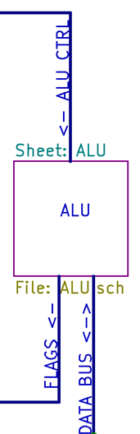
Figure 1: Relevant part of top level block diagram
The relevant sections of Ref 2 that define the signals used / provided by the ALU are:
- 2.1 Overview of Data Bus
- 3.1 Common bus signals (not shown in Figure 1)
- 3.8 ALU CTRL bus
- 3.9 FLAGS bus

ALU Inputs and Outputs
All the inputs to, and outputs from, the ALU are listed in Table 1. Some names have been shortened for use as local names in this document.
Table 1: ALU Inputs and Outputs
Ref 2 Full Name | Local Name | Type
CLOCK | CLOCK | Input
ALU_MODE | MODE | Input
SELECT_ALU_DESTA | SELA | Input
SELECT_ALU_DESTB | SELB | Input
SELECT_ALUO_SRC | SELO | Input
DATA_BUS | DBUS | Input / Output
FLAG_S | FLAG_S | Output
FLAG_V | FLAG_V | Output
FLAG_N | FLAG_N | Output
FLAG_Z | FLAG_Z | Output
FLAG_C | FLAG_C | Output

The main reason for shortening the names is for convenience, particularly to avoid cluttering the block diagram shown in Figure 2.

ALU Block Diagram
Figure 2 shows the level 1 block diagram for the ALU.
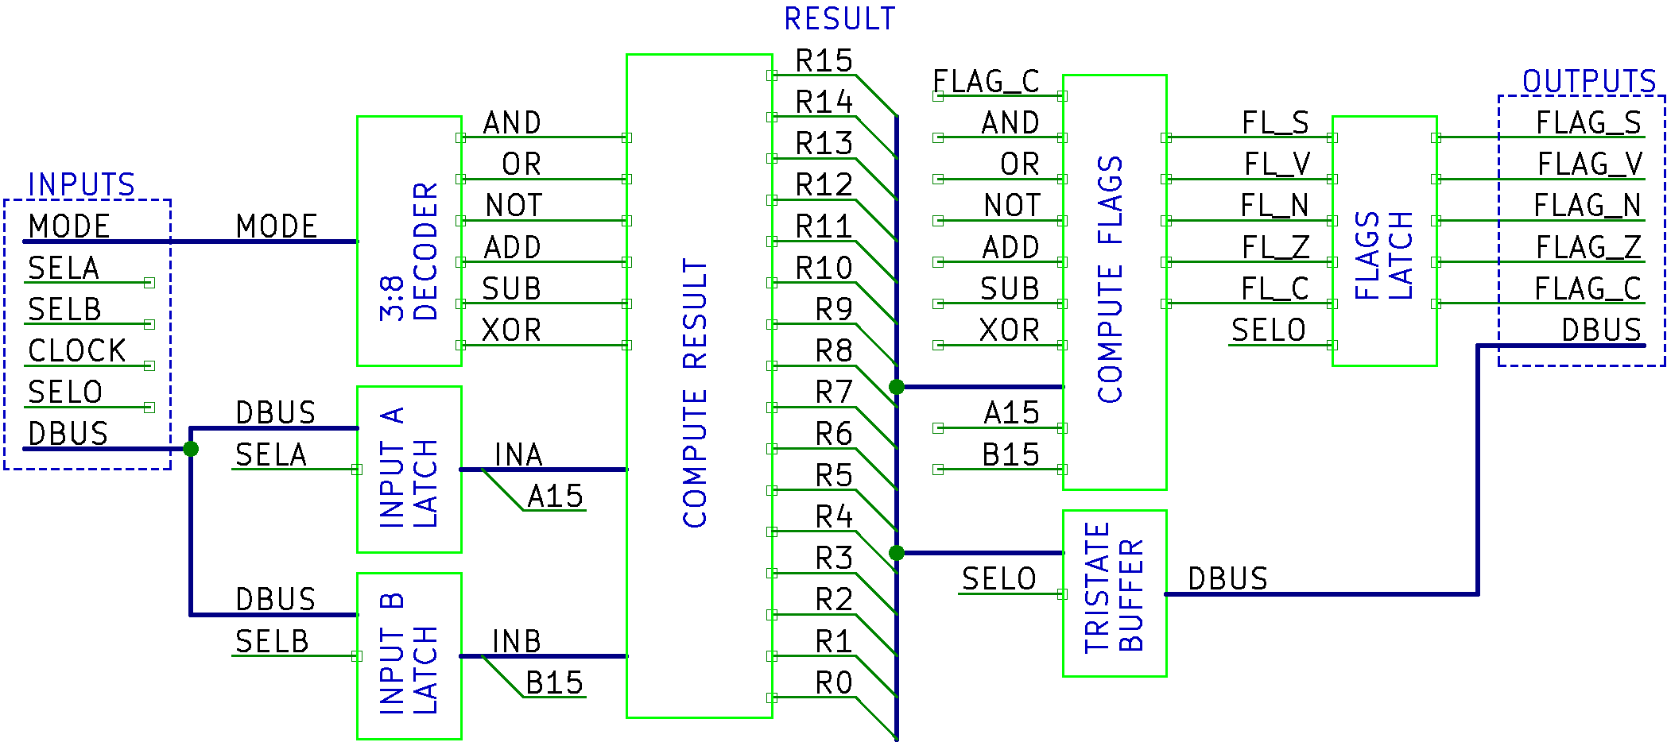
Figure 2: ALU Level 1 Block Diagram
All of the signals on Figure 2 flow from left to right, except for the FLAG_C input to “COMPUTE FLAGS”.

Details for Each of the Blocks Shown in Figure 2
The following sub sections, one per block shown in Figure 2, define the function of each block.

3:8 Decoder
The function of this block is to convert the 3 bit MODE value into one of the possible 6 valid modes (AND .. XOR). The two spare / invalid mode outputs are not shown.
This should be sufficient information for producing a schematic diagram for this part of the ALU without needing any further level 2 design.

Input A Latch
The function of this block is to store the value from the data bus when that value is presented to the ALU on the data bus.
The rules for when the value on the data bus should be stored in this latch are defined in ref 2 section 2.1.1 (Reading from the Data Bus).
This should be sufficient information for producing a schematic diagram for this part of the ALU without needing any further level 2 design

Input B Latch
Same as Input A Latch, except this uses SELB rather than SELA.

Compute Result
This function of this block is to compute the result using the 16 bit outputs from Input Latches A/B and the one active signal from the 3:8 decoder that defines what operation should be performed.
This complex block will need a level 2 block diagram and further text to define the function of each block on that level 2 diagram.

Compute Flags
This function of this block is to compute the flags for the result using the result bits, bit15 of input A/B, and the one active signal from the 3:8 decoder that defines what operation was performed.
The reason this has the previous value of FLAG_C as an input is because there are some operations which don’t change the carry flag.
See ref 2 section 3.9 for the Boolean operations required to set the correct flag values for each mode.
This complex block will need a level 2 block diagram and further text to define the function of each block on that level 2 diagram.

Tristate Buffer
The function of this block is to output the result on to the data bus.
The rules for when this buffer should be enabled to output on the data bus are defined in ref 2 section 2.1.2 (Writing to the Data Bus).
This should be sufficient information for producing a schematic diagram for this part of the ALU without needing any further level 2 design.

Flags Latch
The function of this block is to store the flags indefinitely, until the next time the ALU outputs a result on the data bus. This block permanently outputs the flags. It doesn’t have a tri-state output.
This latch will store the values for FLAG_S to FLAG_C
The way in which SELO is used to store data in this latch is as follows:
The implementation of this may choose between latches with two different types of control:
- “Edge triggered” where a change in level on the latch input causes data to be stored, or
- “Level triggered” where a specific level on the latch input causes data to be stored
If using an edge triggered latch for the implementation:
- The values will be stored when SELO changes from high to low.
If using a level triggered latch for the implementation
- The values will be stored when (!SELO AND CLOCK) is high.
This should be sufficient information for producing a schematic diagram for this part of the ALU without needing any further level 2 design.

References
- AVR Instruction Set Manual
- CpuDesign.docx
- L1IsSequences.xlsx

This left to right flow is a good practice. It’s also how schematics should flow. Experienced hardware engineers will try to draw schematics with left to right flow, and will find this flow much easier to follow than some random flow pattern.

